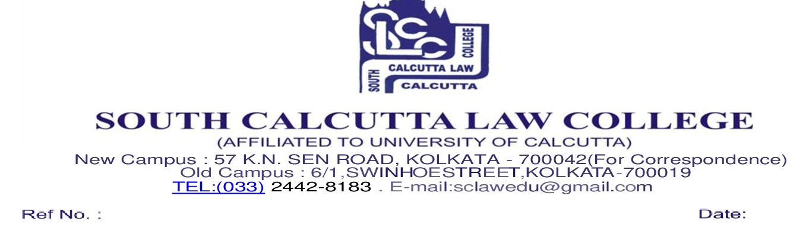

**LL.M. Part II (2020 – 2022) students Dissertation topic**

**DR. NABAMITA PAUL RAY**

|  |  |
| --- | --- |
| Student Name | Dissertation Topic |
| NAMRATA CHAKRABORTY | A CRITICAL ANALYSIS OF CUSTODIAL VIOLENCE AND PRISON REFORMS IN INDIA |
| JASODHARA GHOSH | SAME SEX MARRIAGE IN INDIA : CONSTITUTIONALITY , JUDICIAL VIEW & IMPACT ON LEGAL FRAMEWORK IN INDIA |
| HIMANI GAUTAM | ROLE AND RIGHTS OF VICTIM IN THE INDIAN CRIMINAL JUSTICE SYSTEM : A CRITICAL EVALUATION |
| ANAMIKA | CYBER ATTACKS AND DATA PRIVACY IN INDIA : ISSUES AND CHALLENGES OF A BODY CORPORATE |

**DR. NAYNA CHATTERJI**

|  |  |
| --- | --- |
| Student Name | Dissertation Topic |
| SUMANA MONDAL | EXPLORING THE INTERSECTION OF INTELLECTUAL PROPERTY  AND HUMAN RIGHTS : BALANCING INNOVATION AND ETHICAL CONSIDERATIONS. |
| DEBOLINA BANERJEE | MEDICAL NEGLIGENCE IN INDIA : A CRITICAL ANALYSIS WITH SPECIAL REFERENCE TO THE CONSUMER PROTECTION LAWS. |
| CHANDRIKA CHATTERJEE | PROTECTION OF CONSUMERS AGAINST UNFAIR TRADING WITH SPECIAL REFERENCE TO CONSUMER PROTECTION LAWS IN INDIA |
| SUSMITA PRAMANIK | CRITICAL ANALYSIS ON PLEA BARGAINING IN INDIA |

**DR. PRADIP GHARAMI**

|  |  |
| --- | --- |
| Student Name | Dissertation Topic |
| RUDRA SINGH | INFRINGEMENT OF COPYRIGHT AND LAWS RELATING TO PROTECTION OF COPYRIGHT IN INDIA : AN EVALUATION |
| SREEMOYEE DATTA | ONLINE SHOPPING AND CONSUMER PROTECTION WITH THE SPECIAL REFERENCE TO INDIA: CONTEMPORARY LEGAL ISSUES & PROTECTION. |
| ARPAN KUNDU | UNIFORM CIVIL CODE IN MODERN INDIA : AN ANALYTICAL STUDY |

**MR. ANIL KUMAR PRASAD**

|  |  |
| --- | --- |
| Student Name | Dissertation Topic |
| SARMISTHA SARKAR | THE LAW RELATING TO CYBER FRAUDS IN INDIA : AN ANALYTICAL  STUDY |
| PRONOY GANGULY | THE LEGAL SCENARIO OF GANG RAPE IN INDIA : AN ANALYTICAL  STUDY |
| KAZI FERDAUSI SULTANA | STATUS OF SERIAL KILLERS IN INDIA WITH SPECIAL REFERENCE  TO CRIMINOLOGICAL THEORIES : AN ANALYTICAL STUDY |

**MR. DIPAYAN MANDAL**

|  |  |
| --- | --- |
| Student Name | Dissertation Topic |
| TARUNIKA PAL | ROLE OF INDIAN JUDICIARY IN SUSTAINABLE DEVELOPMENT  WITH SPECIAL REFERENCE TO THE AIR ( PREVENTION & CONTROL  OF POLLUTION) ACT, 1981 : A CRITICAL STUDY |
| MOULI MAJI | THE LAW RELATING TO FREEDOM OF SPEECH AND EXPRESSION  IN THE ERA OF INTERNET : AN ANALYTICAL STUDY. |
| TENZING ZIMBA BHUTIA | THE LAW RELATING TO SEXUAL OFFENCES AGAINST CHILDREN IN  INDIA : AN ANALYTICAL STUDY |
| SAYANTI MUKHERJEE | IMPLICATION OF LEGAL AID IN INDIA – A SOCIO LEGAL STUDY |

**DR. ATIN KUMAR DAS**

|  |  |
| --- | --- |
| Student Name | Dissertation Topic |
| OINDRILA SARKAR | STALKING AS A PSYCO – SEXUAL OFFENCE IN INDIA : A  SOCIO – LEGAL ANALYSIS |
| SARANIKA GHOSH | THE LAW RELATING TO CYBER CRIME AGAINST WOMEN IN INDIA :  AN ANALYTICAL STUDY |
| LEENA CHAKRABORTY | A SOCIO – LEGAL ANALYSIS ON MARITAL RAPE IN INDIA. |
| RIYA SARKAR | THE LAW RELATING TO E – COMMERCE IN INDIA : ISSUE AND  CHALLENGES |

**DR. MOUSREE BASISTHA**

|  |  |
| --- | --- |
| Student Name | Dissertation Topic |
| APARNA PATIL | JURISPRUDENTIAL JUSTIFICATION OF THEORIES OF PUNISHMENT  IN INDIA : AN ANALYTICAL STUDY |
| SIBASH DUTTA | A CRITICAL STUDY ON INTERNET BANKING : EVOLUATION AND REGULATORY FRAMEWORK IN INDIA |
| PRIYADARSHINI ROY | THE RIGHTS OF CHILD AFTER SEPARATION OF PARENTS :  A SOCIO-LEGAL STUDY |
| MD. ABDUL GANI | PRESERVATION OF FOREST RESOURCES IN INDIA : A LEGAL STUDY |

