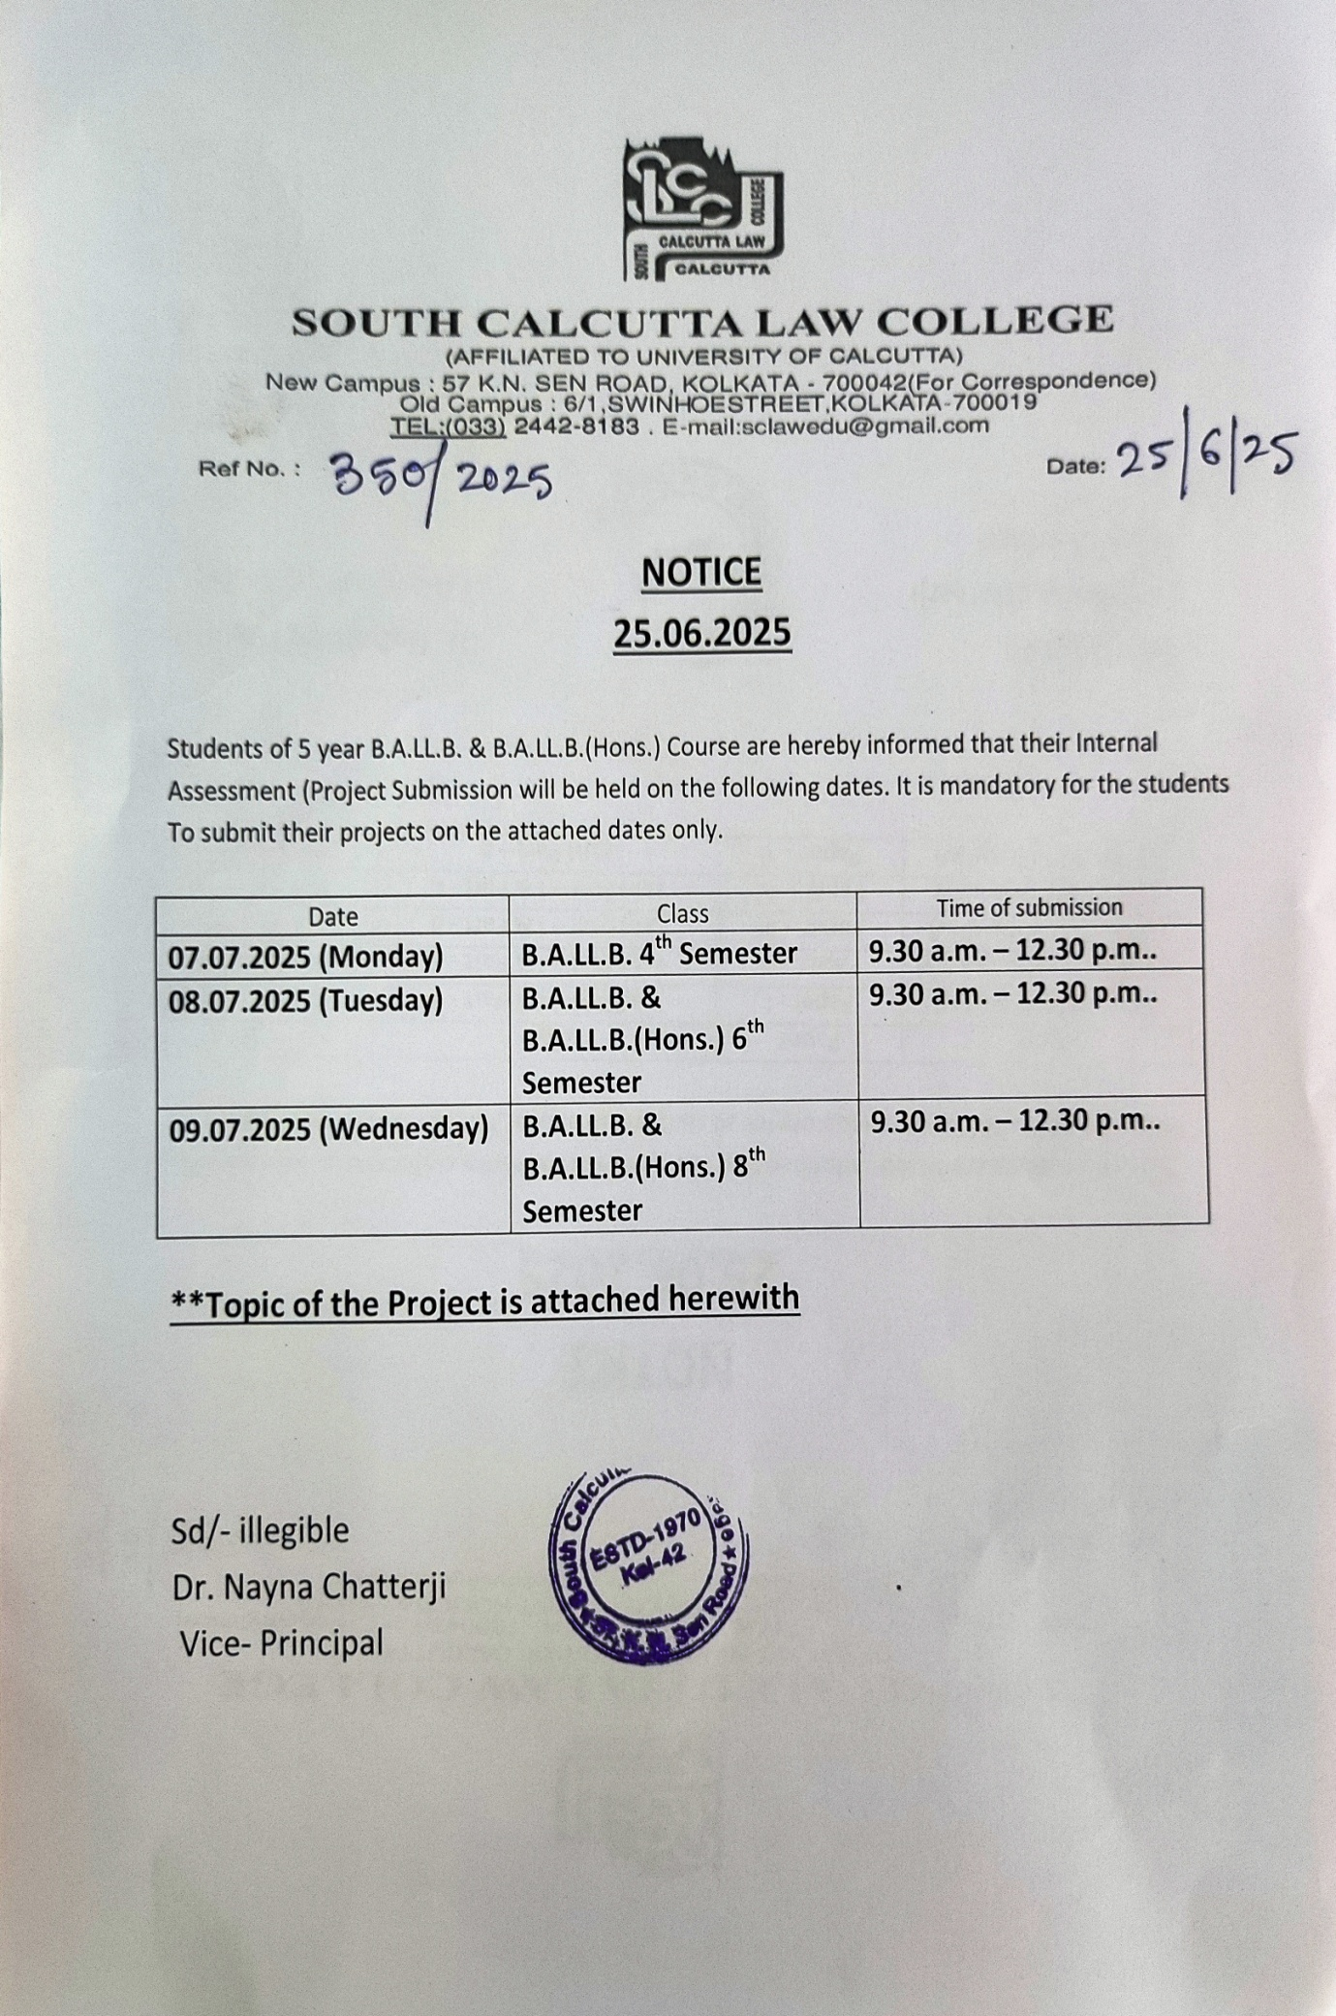

South Calcutta Law College

Project Submission

(Full Marks 20)

**4th Semester**

**Paper I: Political Science -IV**

Discuss the importance of the Government of India Act 1919.

OR

Discuss the importance of the Regulating Act of 1773.

**Paper II: Economics -II**

Define national income. Discuss the matters of estimating national income. Is national income an index of welfare?

Or

Critically discuss quantity theory of money.

**Paper III: Constitutional Law I**

The Law relating to freedom of speech and expression in India: An Analytical Study.

Or

The Legal Scenario of new dimensions of ‘right to life and personal liberty’- an analytical study.

**Paper IV: Law of Crimes I (The Indian Penal Code)**

Critical analysis on criminal conspiracy and its ingredients given in section 120 A of the Indian Penal Code, 1860.

Or

“Act itself does not constitute the crime.” How far this statement is true – Evaluate.

**Paper V: Land Laws including Celling and other Local Laws**

(Answer any one)

* Object and purpose of the West Bengal Land Reforms Act, 1955 – A detailed study.
* A comparative study on the rights and liabilities of the Raiyats and Bargadars.
* A critical study on the right of Pre-emption.
* Penalty provisions under Chapter VIII of the West Bengal Premises Tenancy Act, 1997. A critical note on the usefulness of this chapter.
* Write a note on common areas and facilities as discussed in the West Bengal Apartment Ownership Act.

**6th Semester**

**Paper I: Political Science – VI**

1. Discuss the composition of General Assembly of United Nations.What are it's functions?

or

2. Discuss the composition and functions of Security Council of U.N.O.

**Paper II: Law of Copyright**

A critical analysis on subject matter of copyright under the Patent Act.

Or

Significance of Performer’s rights in the Copyright regime.

**Paper III: Law of Crimes II (Criminal Procedure Code)**

Analysis the law relating to maintenance as provided by the Criminal Procedure Code.

Or

Bail and Anticipatory bail: A critical analysis.

**Paper IV: Civil Procedure Code and Limitation Act.**

“A temporary injunction, under the Civil Procedure Code is a Court order that temporarily restrain the party from doing certain action” – A critical analysis.

Or

Discuss the ‘Law relating to Prescription’ as provided by the Limitation Act.

**8th Semester**:

**Paper I: Human Rights Law and Practice**

Powers and functions of National Human Rights Commission: An Evaluation.

Or

Critically Analysis the role of “International Bill of Rights” for promotion and protection of Human Rights.

**Paper II: Interpretation of Statutes and Principles of Legislations**

**(Answer any one)**

1. Purposive interpretation vs literal interpretation: A Comparative Analysis.
2. Principles of Interpretation of statues: An Analytical Study.
3. Interpretation of Constitutional Law: A Critical Analysis.
4. Principles of utilitarianism: An Analytical Analysis.

**Paper III: Environmental Law**

**(Answer any one)**

* Explain the important doctrines in the field of Environmental law.
* Discuss the role of Public Interest Litigation in protecting environment.
* “Sustainable development is a holistic approach to harmonise human activities with the preservation of natural ecosystem” – a critical study
* Role of Indian Judiciary in protecting environmental degradation and promoting sustainable development – an overview.

**Paper IV: Labour and Industrial Law-I**

“The Medical Benefit Council is an advisory body constituted under the Employees State Insurance Act, 1948, to advice the ESI Corporation on matters related to the administration of medical benefits” – An Analytical Study.

Or

An analytical study on the provisions of the Factories Act, 1948 relating to health of workers.

**8th Semester Honours**

**Paper I: Law of Trade Marks and Design**

The law relating to infringement of trade marks in India: issues and challenges.

Or

The legal scenario of ‘Deceptive Similarity’ in India: An Analytical Study.

**Paper II: Insurance Law**

Critically analysis the law relating to life insurance and its difference with general insurance.

Or

An analytical overview on the law of marine insurance covering ‘maritime perils’.